BUCUREŞTI

2016s

POLITECHNICA UNIVERSITY OF BUCHAREST

FACULTY OF AUTOMATIC CONTROL AND COMPUTERS

COMPUTER SCIENCE DEPARTMENT

|  |  |
| --- | --- |
| upb | cs |

DIPLOMA PROJECT

Automatic Face Verification System

|  |  |
| --- | --- |
| Thesis supervisor:  Prof. Irina Mocanu | George Leotescu |

BUCHAREST

2016

Table of Contents

1. Introduction 3

3. Existing Methods 4

4. Editing Tables 4

5. Editing figures 5

6. Conclusions 6

The abstract should describe the context in 2-3 phrases and give details about the project functionality and implementation in 3-5 phrases.

1. Introduction

Face recognition is a task which is executed on a daily basis, efficiently and without special efforts by any human being. However, this doesn’t hold in the computer’s world where a face recognition problem like any other computer vision problem is a non-trivial one. Detecting a face from an input image, finding its scale and contour, discovering its shape parameters and rendering the original face into a standard shape format, finding a way to represent the face data in a low dimensional space which allows two faces to be compared one to each other, solving the classification problem, all of these are non-trivial problems, which require a robust and efficient solution in order to implement any modern face recognition system.

Speaking of terminology, the “*Face Recognition*”, “*Face Verification*” and “*Face Identification*” terms are tightly related to each other and they can be easily confused. *Face recognition* represents the general topic, which includes both *Face Verification* and *Face Identification* (also referred to as “*Face Authentication*”). On the one hand, *Face Identification* is concerned with finding the identity of a face from a set of known identities (one to many matching). The key aspect is that a face identification system knows precisely the set of identities with which it is dealing, meaning that all the query faces will be compared against a known set of identities. Obviously in this case, the natural approach is to train the system to learn particular features of the registered identities and search for them in the query photos. On the other hand, face verification deals with validating a claimed identity of a face, by comparing it with a model face (one to one matching). The system doesn’t have any information about the identities of the faces that are going to be compared so an identity specific training cannot be done here. The key aspect is that the system needs to be general enough, in order to be able to deal with different identities, without losing its accuracy. It is obvious that a tradeoff needs to be done between flexibility (do we need to re-train the system when a new identity is added to the system?) and accuracy (how accurate can we be when validating the identity of a person, using only one sample of its face?). Even though we saw that a *Face Verification System* is different comparing to a *Face Identification System*, they have a lot of things in common. There are a lot of methods (image pre-processing, data representation, classification methods) which are employed by both systems. Even though the face recognition research field is a wide one, any improvement brought in any level can have wide ramifications.

In the last few years, the research in the *Face Recognition* field has focused on five main complementary directions: face detection, landmarks key-points detection, face registration, face description and face representation using statistical methods. Any modern face recognition system includes all these steps but in general it is enough to improve only one of them in order to increase the overall system performance.

* 1. Face Detection

*Face detection* is a computer vision technology with applicability in a wide range of domains, whose purpose is to identify human faces in digital images. The *face detection* process is similar to the natural human behavior of localizing faces in a visual scene. Even though detecting a face is a trivial task for any human being, in the computer’s world, it is a high resource consuming task. The main difficulties come from the fact that in unconstrained environments, faces can be found under different conditions, with variations in scale (face size), location, orientation (in plane rotation – the roll angle of the face), pose (out of plane rotation –the yaw angle of the face), facial expressions, facial special characteristics, different illumination conditions etc., as it can be seen in Figure 1. A good face detection system needs to be robust to all these variations.

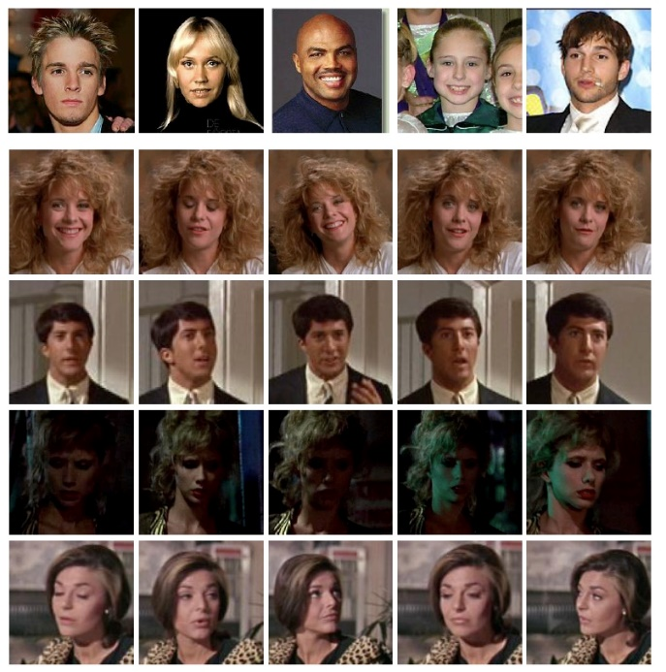

Fig1. Examples of faces with different shapes, in different positions, orientations, under different lighting conditions.

The research in the Face Detection area has made progresses in special in the past decade. Specifically, the work of Viola and Jones [1] has transformed the face detection problem from an almost untouchable task for the computer’s world, into a feasible one. This emerged immediately into real world applications, integrated directly into video or photo camera devices, or image processing software.

The Viola Jones algorithm has at its core three fundamental concepts: the integral image, classifier learning using AdaBoost and the attentional cascade structure [2]. These were at the moment, innovatory ideas in the face recognition research field, which made Viola Jones a powerful and robust algorithm prepared to be used in real time applications.

* + 1. The integral image

*Integral Image*, also known as *Summed Area Table* was first introduced in 1984 by Crow [3] which used it in mipmaps but hasn’t been used in the computer vision field until 2001 when it was employed by Viola and Jones in their face detection algorithm. The integral image represents a quick and effective way of computing the sum of the pixel values of a sub-rectangle contained in an image. What it does, it precomputes the sum of all the possible sub-rectangles of an image, having the top-left corner in the top-left corner of the image. Having all these sums pre-computed, the pixels sum of any rectangle contained in an image can be obtained in constant space (by decomposing the input rectangle into rectangles for which the pixel’s sum represents a known value). Viola Jones employed this mechanism for computing Haar like features as depicted in Figure 2. Using the integral image mechanism, the Viola Jones algorithm computes an enormous number of Haar features (different scales, different locations in the input image) in a small amount of time [2].

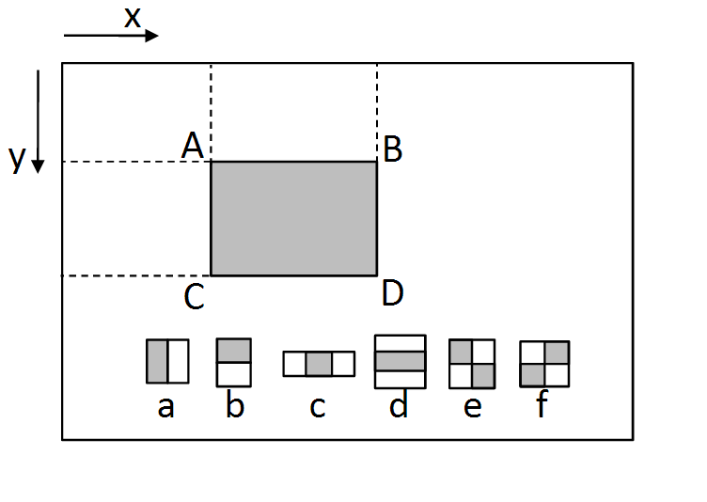

Fig 2. Integral image applied for different types of Haar features (a-f).

* + 1. Classifier learning – Adaboost

Adaboost (Adaptive Boosting) is a Gödel Prize winning machine learning algorithm, formulated by Yoav Freund and Robert Schapire [4]. Even though it’s well known for its contribution to the Viola Jones face detection algorithm, it is a general boosting algorithm which can be used with many other types of machine learning algorithms, in order to improve their performance. Given a set of other learning algorithms (so called “weak classifiers”), AdaBoost combines them into a weighted sum which represents the output of the boosting classifier.

In machine learning, AdaBoost usually refers to a specific method of training a boosted classifier. A boost classifier is defined as any classifier of the form:

$F_{T}\left(x\right)= \sum_{t=1}^{T}{f_{t}(x)}$ (1)

where, $f_{t}$ represents a weak learner, which takes $x$ as input and determines its object class. The sign of the output value represents the object class while the absolute value gives the confidence of the prediction.

The training algorithm iterates through T steps. At each step $t$, a weak classifier is selected and a corresponding coefficient is determined so that the training sum error $E_{t}$ of the current step is minimized. For a weak classifier, given its output value (also called the hypothesis) for a sample from the training set $h(x_{i})$, the training sum error of the step $t$ ­­­ is given by the formula:

$E_{t}= \sum_{i}{E[F_{t-1}\left(x_{i}\right)+ a_{i}*h(x_{i})]}$ (2)

in which the information belonging to the classifier built on the previous step is embedded as $F_{t-1}\left(x_{i}\right)$, while $a_{i}$ denotes the weight assigned to each sample in order to minimize the overall error. The value of the weight is based on the error value calculated in the corresponding sample, at the previous step. These weight values can be used to inform the training of a weak classifier, using as data the given training samples and the associated weights. For example, decision trees can be generated so that they split set of samples using weights values as priorities. The complete AdaBoost algorithm can be described in a few simple steps, as depicted in Figure 3 [2].

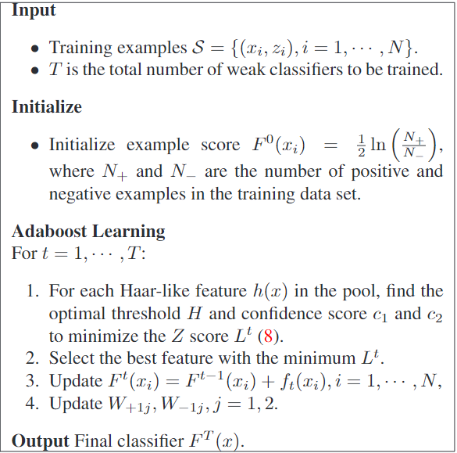

Figure 3. The Adaboost training algorithm

* + 1. The attentional cascade structure

The attentional cascade structure is a key element in the Viola Jones algorithm which allows it to reject negative samples in an incipient phase. In order to do that, a set of smaller but thus more efficient classifiers are used, each of them being trained to reject the negative samples and to keep the positive ones. Thus the whole decision process takes the shape of decision tree, optimized to reject the negative samples as soon as possible. Figure 5 [2] depicts the basic structure of the decision tree, sometimes referred to as a “cascade”. Each node contains a variable number of classifiers, which typically is bigger as the index of the node is bigger relative to its position in the cascade structure (after the obvious negative samples are rejected, it’s more and more difficult to decide whether an image should pass to the next node or should be dropped; so a bigger number of classifiers need to be employed).

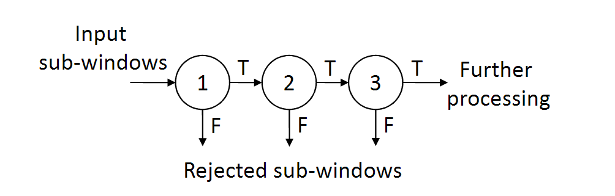

Figure 5. The structure of a cascade classifier, along with the number of classifiers employed by each node

* 1. Facial Landmark Detection

When it comes to face alignment, face analysis, pose estimation or face normalization techniques, detecting facial landmark points is undoubtedly the key stone. Once you have a bounding box around the detected face, the natural follow up is how you detect precisely the shape of the face, its size and special characteristics. For example, one can try to detect the location of different specific features, like the corner of the eyes, the mouth, the tip of the nose, the eyebrows, the full contour of the face. In literature the Facial Landmark Detection problem is also referred to as “Facial Key Point Detection”, “Facial Pose Estimation” or simply “Face Alignment”.

Like any other problem in the Face Recognition research field, a robust and efficient solution for the Facial Landmark Detection problem can improve the solutions of a large set of problems from different research areas.

For example, facial landmarks can be used to align faces to a mean face shape so that after the alignment process is done, specific face characteristics (eyes, mouth, eyebrows) will be approximately in the same place, for all the input faces. This can improve the overall performance of a face recognition system.

Once you have a bounding box around the face, the obvious research problem is to see if you can find the location of different facial features (e.g. corners of the eyes, eyebrows, the mouth, the tip of the nose etc.) accurately. It is natural to think that this will improve the overall performance of a face recognition system and indeed a lot of research has been done in this area and the results confirm it [5][6]. For example, once the location of a small set of landmark points is known, it is possible to estimate the position of the head (the head coordinates in a three dimensional space). In order to do that, an automatic camera calibration system can be employed. To calibrate a camera against a 3D model, implies finding the optimal perspective projection transformation which projects the model from the 3D space into a 2D space in which its shape is as close as possible to the current image shape. By decomposing the projection matrix obtained, one can approximate the head orientation in space [7][8].

As described in [5], after detecting a bounding box around an input face (using an algorithm similar to the Viola Jones algorithm described above) a cascade of regressors is employed.

Each regressor in the cascade is trained to estimate the location of the corresponding key point. An iterative algorithm is employed. At each step, a new prediction is made, using the information obtained at the previous step. Let $x_{i}$ (x, y) represent the 2D coordinates of the $i$ th facial key point of the input image $I$. The vector $S=(x_{1,}, x_{2}, …, x_{p })$ contains the coordinates of all the key points $x_{i}$. We refer to $S$ as the estimated shape of $I$ and we use $S(t)$ to denote the shape of $I$ estimated at the step $t$. Given a regressor $r(I, S)$ which can predict a new value for the estimated shape vector S, we can write the following equation:

$S\left(t+1\right)=S\left(t\right)+r_{t}(I, S\left(t\right))$ (3)

which is used to predicted the shape of the image $I$ at the step $t+1$, using the values predicted at step $t$.

The intial estimation is a generic mean shape. It can be easily obtained by aligning and centering the training images to a scale dependent to the size of the bounding box returned by the face detection algorithm. The whole algorithm of learning the regressors cascade, as described in [5], is depicted in Figure 6.

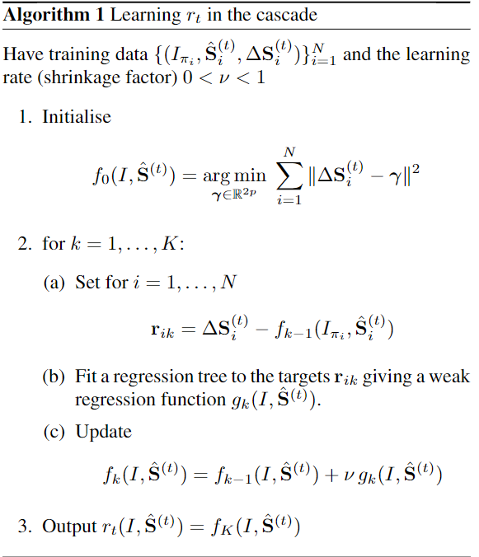

Figure 6. Algorithm for learning a cascade regressor used in facial key points detection

The key component for each regression function $r_{t}$ is a decision tree. Each tree is fit using as weights, the residual components obtained during the gradient boosting algorithm. At each node in the regression tree, a decision is made by comparing the intensities of the pixels in the input face to the intensities of the correspondent pixels in the mean model face. The decision is made using a threshold obtained during the training phase. Given a pixel in the input face, with the position determined by two vectors $u$, $v$ (vectors defined in the query space), the algorithm aims to determine the correspondent pixel in the model shape, its location being defined by $u'$ and $v'$ (vectors defined in the model space). In order to solve this problem, a straightforward solution would be to wrap the original input face into the model shape. However, considering that we are dealing with a sparse representation of the image (only the detected key points are relevant) it is easier to wrap only those pixel locations. This can be easily done by computing a global similarity transform (a two dimensional space transformation, based only on a scaling, translation and rotation) and applying it to each point.

* 1. Face Registration

In the Face Recognition field, there are many applications which require robustness against occlusions, variations in shape or size, different illumination conditions, facial expressions etc. The Face Registration problem aims to reduce all these variations by fitting an input image to a general model thus all the query samples being forced to be defined by the same shape, size, or illumination parameters.

A simple Face Registration application can be developed as a straightforward application of the Key Points Detection algorithm described above. When the fitting algorithm finishes, the similarity transform used to map the original input face into the generic model, is known. As described in [9], decomposing a similarity transform, gives us the in plane rotation angle (roll) and the face scaling factor relative to the model shape. This information can be pumped into a simple face alignment algorithm. The original bounding box (as it was returned by the Face Detection algorithm) is shrank using the face scale determine using the method described above. The rectangle is rotated against the face roll angle and cropped from the input image. Thus as cropped and aligned face is obtained from the input image, with a minimum overhead.

Any face alignment algorithm will try to maximize the correlation between an input face and a standard model. In [10] it is described a face alignment method based on gradient descent optimizations. Comparing to the first method, the algorithm employed in [10] determines the correlation coefficients between the two images by computing complex gradients which capture the images structures (orientation, shape) directly, instead of computing average pixel intensities in specific points. The algorithm represents on optimization of the classic Lucas-Kenade algorithm [11] which was the first algorithm of this type. The main characteristic of a gradient descent algorithm is that it is an iterative learning method. At each step, the method solves a least squares problem, having the Hessian matrix pre-computed (it is constant between different iterations). In general, the $l2$ norm is used to compute the error function. However, it is obvious that optimizations can done on this level in order increase the overall system accuracy. In general, for algorithms in this category, a tradeoff needs to be done between the robustness of the algorithm and its complexity. A robust system replaces the $l2$ norm with a complex error function. Thus the value of the weights used are updated at each step. In this case the Hessian matrix doesn’t have a constant value across different steps. Its value needs to be determine at each iteration, increasing thus the overall system complexity.

1.4 Face description using statistical methods

In the Face Recognition research field, statistical methods are especially used to learn face representations in a low dimensional space. Given an input image represented in a high dimensional space, a statistical method will encode the image data into a low dimensional space, an euclidean space. In the new space a large set of metric learnings techniques can be applied in order to fit a classifier to the system requirements. In the last few years, the research in this field has focused on finding new image representations or efficient ways of merging two or more consecrate representations (like SIFT, HOG) into a single one, more efficient and robust comparing to any of them.

1.4.1 CCA – Canonical Correlation Analysis

In [11] it is proposed a novel method a fusioning two or more features vectors into a single one which is more discriminative than any of the input feature vectors. The algorithm is based on Canonical Correlation Analysis, a method widely used before to analyze associations between two sets of variables [12].

CCA is a statistical method which uses the mutual relationship between two random variables in order to determine the maximum correlation between them. Generally speaking, it as important as any others statistical methods techniques like PCA (Principal Component Analysis) or LDA (Linear Discriminant Analysis) and it has been used with success in different research fields like signal processing, computer vision, speech recognition etc. The method behind CCA was first introduce by H. Hotelling in 1914. The problem is formulated in the following way: given two random variables, $X$ and $Y$, centered in zero, find a pair of projection directions named, α and β that maximize the correlation between the two sets of data projected onto them. Specifically, find the value of α and β so that the variables $a_{1}= α *X$ and $b_{1}= β*Y$ are as correlated as possible. The pair ($a_{1}$, $b_{1}$) is called the first pair of canonical variables. The process can continue, finding the second, third and so on, pairs of canonical variables. The key aspect is that, the variables inside a pair of canonical variables are correlated one the each other as much as possible but two different pairs of canonical variables are uncorrelated. Thus, in order to analyze the correlation between two random variables it is enough to analyze their first pairs of canonical variables.

1.4.2 Fisher Vector

The concept of Fisher Kernels represents a powerful framework in the pattern classification research field. The basic idea consists in representing an input signal, using a gradient function determined from a generative mixture model and passing the results to a discriminative classifier. Thus, the concept of Fisher Kernels includes the advantages of two different and complementary approaches: processing data using a generative model and using classifiers trained in a discriminative way. In the last few years, Fisher Kernels have been used successfully in the image classification field. Particularizing the problem, the Fisher Kernels concept can be applied directly using an image as the input signal and a Gaussian Mixture Model as the generative model. The role of the Gaussian Mixture Model is to determine the distribution of the extrinsic characteristics in the input image.

Given a visual vocabulary, the problem of describing an image is reduced to counting how many times each word from the vocabulary appears in the query image. From this point, any classifier can be employed for categorizing the histograms obtained. The main research in this area has focused in finding an accurate visual vocabulary which can describe in an efficient and discriminative way any image received as input. Over time, a lot of algorithms employing different methods have been used, e.g. the k-means algorithm, Gaussian Mixture Models, mean-shift algorithm etc.

1.4.2.1 K-means algorithm

K means clustering is a method originally used in signal processing, whose purpose is to cluster n observation variables, into k clusters so that each clustered variable belongs to the cluster with the nearest mean value. Even though this is an NP hard problem, there are efficient heuristic algorithms which converge to the local optimum.

The problem can be formulated in the following way: given a set of $n$ observations $X=(x_{1}, x_{2}, …, x_{n})$ where each observation $x_{i}$ is a $d$ dimensional variable, the k-means algorithm tries to partition these variables into $k$ (with $k≤n)$ sets, $S=\{S_{1}, S_{2}, …, S_{k }\}$ so that each variable corresponds to the set in which it is closest to the set mean value. In other words, the K-means algorithm partitions the variable into different sets so that the within-cluster sum of squares is minimized. For each variable, the algorithm finds the value of the expression:

$min\sum_{i=1}^{k}{\sum_{X}{{\left\|x-μ_{i}\right\|}^{2}}}$, (4)

where $μ_{i}$ denotes the mean of the points contained in the set $S_{i}$. Figure 7 depicts a simple implementation for the K-means algorithm.

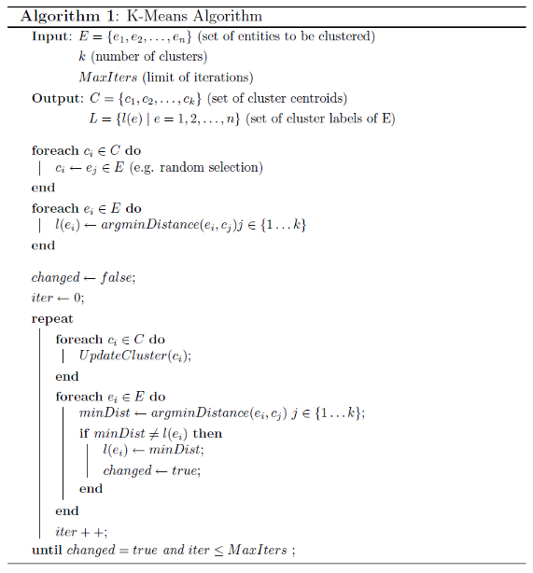

Figure 7. A simple implementation for the K-means clustering algorithm

A general problem consists in finding the initial mean values. A popular solution, as illustrated above consists in randomly choosing $k$ samples to represent each sub-set. However it is important to keep in mind that the results produced depend on the initial values of the means so when a bad choice is made there are high chances for a suboptimal result to be found. The standard solution consists in re-iterating the algorithm with a number of different starting points. It is also important to remark that the results depend on the number of clusters, $k$. This is troublesome because we cannot known how many clusters should exist in order to obtain an optimal solution (for example, how you decide if the data returned by a 3-means clustering algorithm is better comparing to a 2-means clustering algorithm?).

1.4.2.2 Gaussian Mixture Models

A Gaussian mixture model is a probabilistic model that assumes all the data points are generated from a mixture of a finite number of Gaussian distributions with unknown parameters. One can think of mixture models as generalizing k-means clustering to incorporate information about the covariance structure of the data as well as the centers of the latent Gaussians.

A general mixture model is a hierarchical model, containing the following components:

1. *N* random variables corresponding to different observations, each assumed to be distributed according to a mixture of *K* components. Each component is assumed to belong to the same family of parameters (e.g. for a Gaussian Mixture Model, all components follow a Gaussian distribution).
2. *N* corresponding random latent variables, each specifying the identity of the mixture component of each observation
3. A set of *K* normalized mixture weights. Each mixture weight represent a probability value between 0 and 1. The sum of all the mixture weights is equal to 1.
4. A set of *K* parameters, each specifying the parameter of the corresponding mixture component. Each parameter represents a set of parametric values. E.g. for a Gaussian Mixture Model, each component is represented by a *mean* and a *variance* value.

Figure 8 depicts the plate notation of a Gaussian Mixture Models, along with the notation used.

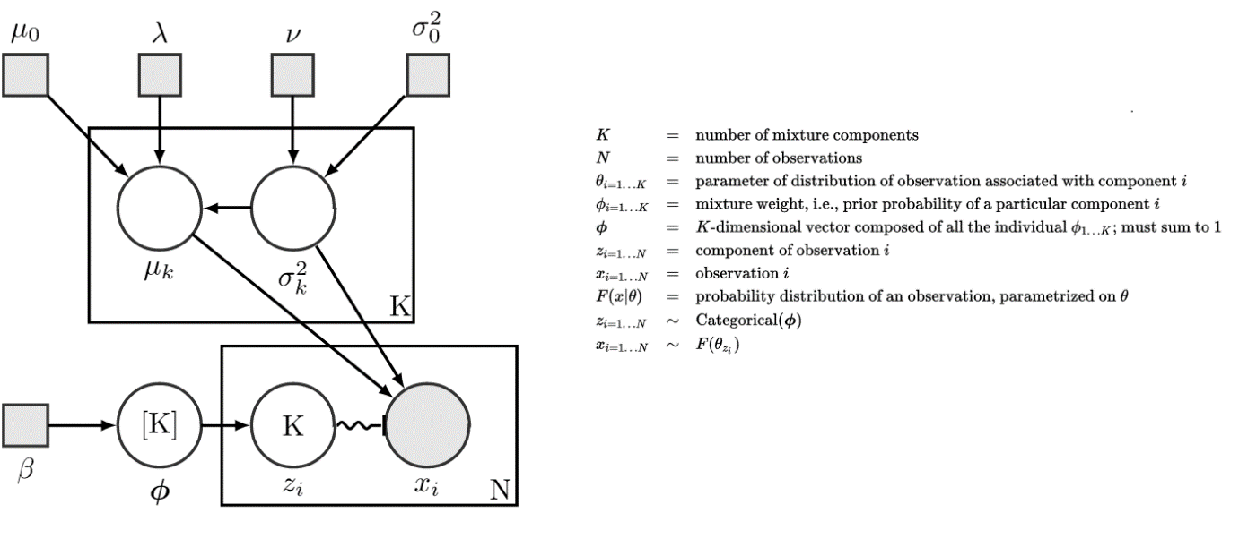

Figure 8. The plate notation of a Gaussian Mixture Model, along with the notations used.

1.4.2.3 Mean Shift

Mean shift is a [non-parametric](https://en.wikipedia.org/wiki/Non-parametric) [feature-space](https://en.wikipedia.org/wiki/Feature_space) analysis technique for locating the maxima of a [density function](https://en.wikipedia.org/wiki/Density_function). It has been introduced long back in 1975, but wasn’t widely used until direct applications of it were found in the computer vision research field. At its core, it is an iterative algorithm which is used for finding modes, clusters etc.

The algorithm considers the image feature space as an empirical probability density function. An image represents a set of points so the mean shift algorithm considers them as being sampled by the density function which needs to be find out. By analyzing the probability function, if dense regions are encountered, they correspond to the local maxima value of the function (also referred to as the function mode). For each point in the data set, mean shift associates it with the nearby peak of the function. A window is defined around it and the algorithm computes the mean value of the data point. After that, the center of the window is shifted to the mean value and the same steps repeat until the algorithm converges. This can be visualized as a window moving step by step to denser and denser regions of the dataset, until it is centered in the peak value.

Therefore, the algorithm can be described in 4 simple steps:

1. Compute a window w around each point $x_{i}$ in the dataset
2. Compute the mean shift vector $m(x_{i})$
3. Translate the estimated window with $m(x_{i})$
4. Repeat until the algorithm converges

The algorithm described above is a time consuming algorithm ( $O\left(n^{2}\right)$ complexity, *n* representing the number of points in the data set). However many improvements can be made in order to make the algorithm to converge faster. A possible solution would consist in allowing the bandwidth parameter (the window size) to vary for each data point. For example the value of the bandwidth for a given point $x_{i}$ could be found by applying a K Nearest Neighbor algorithm. Another solution would be to alter the data points during the execution of the mean shift algorithm, for example by using a Gaussian Kernel.

As a conclusion, even though K Means is not a parametric algorithm, it requires the value of the bandwidth parameter to be known. Even tough, in order to find it, different solutions can be employed (like the K Nearest Neighbor Algorithm), it is important to notice that the choice of the bandwidth parameter will influence directly the number of clusters generated and the convergence rate of the algorithm. When applying the K Nearest Neighbor Algorithm, the size of K will influence directly the bandwidth parameter generated. As a common rule, it is recommended to increase the value of k with the size of the input data.

1.4.2.4 Methods used in generating the Visual Vocabulary

Analyzing the research methods in this field, one can observe that even in the case of a small database, with a limited number of classes, the best results were obtained when a visual vocabulary with a large number of entries was employed. Obviously using a big visual vocabulary implies a higher computational cost, because given a base vocabulary and an input object, the cost of creating its histogram depends directly on the vocabulary size. This is why a lot of research has been done in this area, trying to find a way of generating a visual vocabulary, as compact as possible without losing the robustness and overall performance of the system. A possible solution consists in organizing the vocabulary in a tree structure (Randomized Tree Structure). Even though the lookup time for a visual term will decrease in time, this solution doesn’t scale. Another solution is based on the Information Bottleneck Principle. The e Information Bottleneck Principle finds the best tradeoff between accuracy and the size of the visual vocabulary employed. The method represents a probabilistic algorithm rather than a statistical one. Given a distance metric between two words in the visual vocabulary and a distance matrix, it computes the transition probabilities between two sample pairs. Given the transition probabilities, one can compute the probability for each sample word of being included in the final visual vocabulary.

Even though both methods described above fulfilled their expectations (for example by reducing five times the size of the visual vocabulary, without any loss in the system accuracy) the fundamental aspect is that the vocabulary obtained is not a universal one. The problem that emerged came from the fact that the system wasn’t flexible enough. In order to add new classes, the whole system needed to be retrained. Based on these, it became obvious that the idea of generating a vocabulary which was both compact and universal, was almost an impossible one. However a pseudo-solution appeared, based on the K Means algorithm. It consisted in building a visual vocabulary for each different class employed. Even though it proved to be a flexible approach (the system doesn’t need to be re-trained) it’s doesn’t necessarily reduce the overall computational complexity of the system.

In [14] it is described a method for combining the advantages of a universal vocabulary with the advantages of using a set of smaller vocabularies, one per each class. Thus the K Means problem is transformed into a 2 Means problem. For each class, the universal vocabulary is combined with the corresponding one-class vocabulary. Given an input image, a histogram is computed for all the combined vocabularies. The resulted histograms show for each class if the image is best modelled by the universal vocabulary or by the in-class vocabulary.

1.4.2.5 Principles of Fisher Kernels

The main idea behind the Fisher Kernels consists in representing an image using a model based on a probability function which characterizes the process that might have generated the input signal. Gradient based representations which can be found at the core of the Fisher Kernels, have the great advantage, comparing to the classic methods which employ visual vocabularies (e.g. Bag of Visual Words), that they can use linear classifiers bigger in size. An important decision that needs to be made when designing the generative model behind the Fisher Kernels consists in whether or not to use the class information during the training phase. Specifically, the decision consists in choosing between a Visual Vocabulary learned using a supervised method and a vocabulary learned using a non-supervised one. Definitely, choosing a supervised method will increase the system overall performance but it will also impose limitations on its flexibility (in order to add a new class, the whole system needs to be re-trained).

When speaking about pattern classification methods, there are two distinct directions: generative learning methods and discriminative learning methods. While the methods in the first category are based on modeling a density probabilistic function which describes the input object or the process that generated it, the methods in the second category handle directly the classification methods, for example by using different metric learning techniques. All these things being said, the generative methods still have a set of properties which make them attractive. For example, the possibility of using data with variable dimensions.

From the beginning, Fisher kernels were designed so that they could combine the advantages of a discriminative learning technique with the advantages of generative one. Using the notation introduce in [14], let $p$ be the density probabilistic function and $X=\{x_{i}, i=1…n\}$, a set of samples used during training. The log-likelihood gradient of $X$ is given by the formula:

$∇_{λ} \log{p\left(X \right|λ)}$ (5)

Intuitively speaking, the log-likelihood gradient describes the directions in which the parameters of the mixture model should be changed so that it will optimally describe the input data. Thus, the input data is transformed from a vector variable in size into a vector fixed in length, whose size depends only on the number of the parameters of the employed model. As the next step, this gradient can be classified using any discriminative classifier. In [14] Fisher Kernels are applied directly on Visual Vocabularies, represented by the means values of a Gaussian Mixture Model.

1.1 Article sections

Each section title is numbered, in sentence case, size 12 pct and bold.

1.1.1 Symbols

Symbols and abbreviations will be defined at first use.

1.1.1.1 Page margins

Page margins are Normal: top, bottom, left and right 2.54 cm.

1.2 Results

Authors must present their methods for producing and analyzing data, their results, and they should also discuss possible limitations of their study.

3. Editing equations

Equations are numbered in a right-aligned list (using tabs), and edited with the equation editor.

 (1)

, (2)



 (3)

4. Editing Tables

Tables are written with 10 pct size fonts.

Table title is centered, bold.

Table numbering follows the order of appearance in text (Table 1, Table 2 etc), with Calibri italic (10 pct) and right-aligned.

Numbers should be right-aligned, as in T_table_text_right.

Text should be left-aligned or centered, as in T_table_text_left or T_table_text_center.

Table 1

Link attributes in MPLS TE

|  |  |
| --- | --- |
| Link attributes | Description |
| Maximum link bandwidth | True link capacity (in the neighbor LSR direction): the maximum amount of bandwidth that can be used on the link |
| Reservable link bandwidth | Maximum bandwidth that can be reserved on the link (in the neighbor LSR direction); if it is larger than the maximum bandwidth, the link is overbooked |
| Unreserved bandwidth | Available bandwidth at each of the eight preemption priority levels (in the neighbor LSR direction); they are initially set at the maximum reservable bandwidth level. |
| Path attribute | Whether the path of the LSP should be manually specified or dynamically computed by Constraint-Based Routing |
| Setup Priority | The attribute specifies which LSP will acquire a certain resource if multiple LSPs compete for it |
| Holding Priority | The attribute specifies whether resources can be withdrawn from an established LSP in order to accommodate requests for a new LSP |
| Resource class or link coloring | Administrative group membership of the link, associated with the link for inclusion/exclusion policies |
| Traffic engineering metric | Specifies the link metric for TE purposes. This metric is not necessarily the same as the IGP metric. |
| Adaptability | Whether to switch the LSP to a new path whose metrics are closer to optimality values (when one becomes available) |
| Resilience | The attribute that decides whether to reroute the LSP when the current path is affected by failure |

5. Editing figures

Figures must be centered, aligned without first line indentation.

Figures are numbered according to their appearance in text, and legends are written on the same line, centered, without first line indentation, with Calibri 10 pct, under the figure.



Fig. 1. Figure legends are centered (Calibri 10 pct).

6. Conclusions

The “Conclusions” title is numbered, written in sentence case, 12 pct and bold.

The article ends with a section of Conclusions, presenting the authors’ contribution to knowledge in the specific field.

The authors should also discuss here the applicative potential of their results, and directions for further research.

bibliography

The Bibliography title is written in T_bibliography title, Calibri 12 pct, all caps, expanded spacing with 2 pt, centered.

References are numbered according to the order of their appearance in text. Text references are indicated by the number of the title between square brackets, such as [2].

Each bibliographic entry should mention: initial of the first name, family name, title, publishing house, place and year or periodical title, volume, number, year, initial and final pages. Authors names are written in italics (10 pct).

For Romanian books and articles a translation of the title will be inserted in parentheses.

[1] P. Viola, M. Jones – Robust Real-time Face Detection, International Journal of Computer Vision, Vol. 57, Issue 2, pp. 137-154, 2004

[2] C. Zhang, Z. Zhang - A Survey of Recent Advances in Face Detection, Technical report, Microsoft Research, 2010

[3] Lewis, J.P – Fast template matching, Proc. Vision Interface. pp. 120–123, 1995

[4] A decision-theoretic generalization of on-line learning and an application to boosting, Journal of Computer and System Sciences 55, 119-139, 1997

[5] V. Kazemi, S. Sullivan – One millisecond face alignment with an ensemble of regression trees, [IEEE Conference on Computer Vision and Pattern Recognition](http://ieeexplore.ieee.org/xpl/mostRecentIssue.jsp?punumber=6909096), pp. 1867-1874, 2014

[6] X. Cao, Y. Wei, F. Wen, and J. Sun. Face alignment by explicit shape regression. In CVPR, pages 2887-2894, 2012

[7] T. Hassner – Viewing Real-World Faces in 3D,  [IEEE International Conference on Computer Vision](http://ieeexplore.ieee.org/xpl/mostRecentIssue.jsp?punumber=6750807), pp. 3607-3614, 2013

[8] T. Hassner and R. Basri. Example based 3D reconstruction from single 2D images. In Proc. Conf. Comput. Vision Pattern Recognition, 2006

[9] S. Umeyama Least-squares estimation of transformation parameters between two point patterns, IEEE Transactions on Pattern Analysis and Machine Intelligence (Volume:13 , Issue: 4 ), pp. 376 – 380, 1991

[10] [G. Tzimiropoulos](http://ieeexplore.ieee.org/search/searchresult.jsp?searchWithin=%22Authors%22:.QT.Georgios%20Tzimiropoulos.QT.&newsearch=true) , [S. Zafeiriou](http://ieeexplore.ieee.org/search/searchresult.jsp?searchWithin=%22Authors%22:.QT.Stefanos%20Zafeiriou.QT.&newsearch=true) – Roboust and efficient parametric face alignment, [International Conference on Computer Vision](http://ieeexplore.ieee.org/xpl/mostRecentIssue.jsp?punumber=6118259), pp. 18471-854, 2011

[11] B.D. Lucas andT. Kanade, An iterative image registration technique with an application to stereo vision, Interna-tional joint conference on artificial intelligence, pp. 674–679, 1981

[12] M. Haghighat , M. Abdel-Mottaleb, W. Alhalabi,  [Expert Systems with Applications](http://www.sciencedirect.com/science/journal/09574174), [Volume 47](http://www.sciencedirect.com/science/journal/09574174/47/supp/C), pp. 23–34, 2016

[13] Q. Seun, S. Zeng, Y. Liu, P. Heng, D. Xia, A new method of feature fusion and its application in image recognition, [Pattern Recognition](http://www.sciencedirect.com/science/journal/00313203), 2015

[14] F. Perronnin – Fisher Kernels on Visual Vocabularies for Image Categorization,  [IEEE Conference on Computer Vision and Pattern Recognition](http://ieeexplore.ieee.org/xpl/mostRecentIssue.jsp?punumber=4269955), pp. 1-8, 2007

[1] C. Soviany, Embedding Data and Task Parallelism in Image Processing Applications, PhD Thesis, Technische Universiteit Delft, 2003

[2] A. Mauthe, D. Hutchison, G. Coulson and S. Namuye, “Multimedia Group Communications Towards New Services”, in Distributed Systems Eng., vol. 3, no. 3, Sept. 1996, pp. 197-210

[3] V. I. Arnold, Metodele matematice ale mecanicii clasice (Mathematical models of classic mechanics), Editura Ştiinţifică şi Enciclopedică, Bucureşti, 1980

[4] *** COSMOS/M – Finite Element System, User Guide, 1995.